Title of Paper Should Be Centered and Type with Bold Font

Author’s name should be centered 12-point Times Font type
Author’s name should be in order of given name, middle name initial and family name,
Firstname LASTNAME¹ and Firstname M. LASTNAME²

¹ Author affiliations should be centered 10-point italic type
² Author affiliations should be centered 10-point italic type

The abstract should be 10 point justified type with a 5 mm indentation (both of left and right) and within the 200-word limit. It should be an explicit summary of the paper that states the problem, the methods used, and the major results and conclusions. It should also contain relevant key words that would allow it to be found in a cursory computerized search. The first line should be indented 5 mm from the left margin.

Keywords: Five to ten keywords or phrases should be given. Except in special cases, type all keywords in lower-case letters separated by commas. They should be 10 point justified type with a 5 mm indentation.

1. INTRODUCTION

This document is a journal-page image for Microsoft Word. Paper size should be A4 (21.0 x 29.7 cm). Main text is in two-column format. All fonts for text should be Times or Times New Roman and Symbol. Text should be 10 pt., the title should be 14 pt., and the affiliation and references should be 10 pt.
Major headings (“Head 1” in the template style list) are bold 11-point font, flush left, and numbered (1. 2. 3. etc.) Subheadings and Sub-Subheadings are bold, flush left, and numbered as 1.1, 1.2, etc. and as 1.1.1, 1.1.2, etc., respectively.

2. EQUATIONS AND FIGURES

Use either the Microsoft Equation Editor or the MathType add-on for all math objects in your paper. "Float over text" should not be selected. A math object is any equation or fragment containing mathematical symbols (including Greek characters, superscripts and subscripts) that appears either in-line (in the flow of normal text) or as a display equation (in its own space between lines of text).
In particular, you should avoid using Word fonts or symbols for in-line single variables with superscripts or subscripts. Use italics for emphasis; do not underline.
Equations should be indented 10 mm. Equation numbers should appear at the right-hand margin, in parenthesis. For long equations, the equation number may appear on the next line. For very long equations, the right side of the equation should be broken into approximately equal parts and aligned to the right of the equal sign. The equation number should appear only at the right hand margin of the last line of the equation. For example,

$\tilde{f}(\text{x,}μ,E)=−ρ⋅∇f_{M}(\text{x,}E),$ (1)
where$ρ={b×v_{}}/Ω$.
$\begin{aligned}\int{F_{\text{ij}}}(r,ϕ)\text{dr}dϕ=\left[{σr}_{2}/\left(2μ_{0}\right)\right] \\ ×\int{ \text{exp}\left(−λ\left|z_{j}−z_{i}\right|\right)λ^{−1}J_{1}\left({λr}_{2}\right)}dλ \text{.}\end{aligned}$ (2)

Figures should be included directly in the document. All photographs must be in digital form and placed appropriately in the electronic document. All illustrations must be numbered consecutively with Arabic numbers. The size of a figure should be commensurate with the amount and value of the information conveyed by the figure. Only white and black printing of figures is available.
Place figure captions below the figures. The captions should be indented no margins. The abbreviation “Fig.” for figure should appear first followed by the figure number and a period. Captions should be in 9 pt. Roman Font.

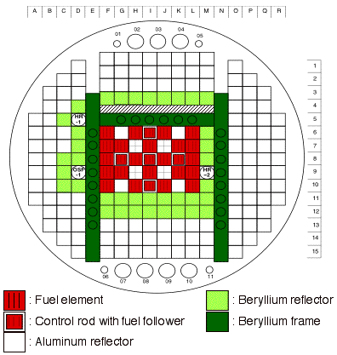

Fig.1. Core arrangement of JMTR.

Table 2 ***********
Density : > 1.84 g/cm³
Tensile strength : > 275 MPa
Yield strength : > 206 MPa
Total Elongation : > 1 %

4. CONCLUSIONS

REFERENCES

The journal follows the following citation style: For journal articles, authors are listed first, the volume number in bold, inclusive page numbers, and the year in parentheses.
References should appear at the end of the article. The font should be 9 pt., aligned left. At the point of citation within the main text, designate the reference by typing the number in after the last corresponding word [1]. Reference numbers should precede a comma or period [2]. Two references [3,4], should be included together, separated by a comma, while three or more consecutive references should be indicated by the bounding numbers and a dash [1-4].

- Y. Lastname and K. Lastname, J. Plasma Fusion Res 1, (2001) 40-45.
- L. lastname, Physics of Fully Ionized Gases (Interscience Publishers, New York, 1959) p. 20.

